Hi Sunny –

The purpose of this next project will be to add our interactive charts to a website made using the Wix website editor.

I currently have a website draft made and the purpose of the site is to explain CSI and all its features. The URL for the site can be viewed here: <https://dshay04.wixsite.com/csi1>

You will notice that the site currently is using placeholder images where the interactive charts would presumably be.

The goal for this stage of the project will be just to insert the main CSI graph (and replace the stock image currently there). Please see below:

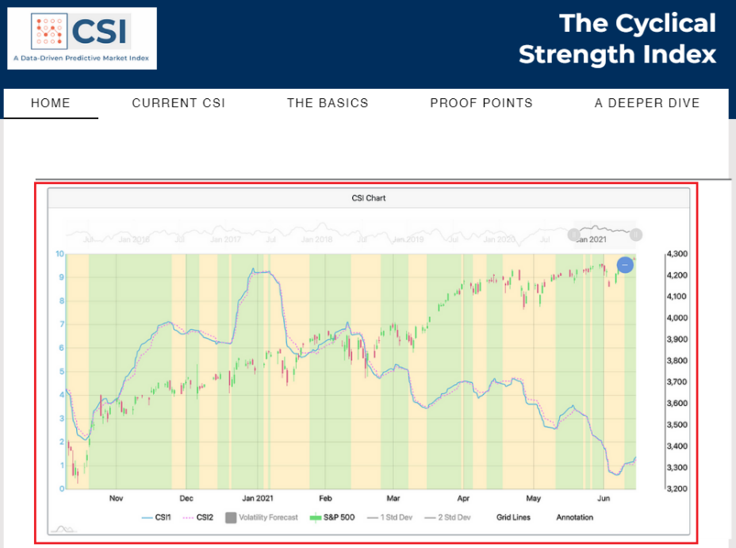

There is one complication for implementing the charts. First, the good news is that Wix provides an easy method for implementing amcharts:

<https://www.amcharts.com/docs/v3/tutorials/adding-charts-maps-wix-website/>

However, the difficult part of this implementation will be fetching the data for the chart from our pythonanywhere webapp. Fortunately, Wix provides a solution that I believe will be suitable for this. Wix calls this functionality “fetch()”. I have included a few weblinks below that I saw that lead me to believe that it will be possible to link our pythonanywhere backend to a Wix frontend.

<https://www.wix.com/velo/forum/coding-with-velo/solved-connecting-wix-code-to-python-backend>

<https://www.wix.com/velo/forum/coding-with-velo/python-machine-learning-backend-program>

<https://www.wix.com/velo/reference/wix-fetch/fetch>

I decided to use a website editor (i.e., Wix) instead of building a website using Django as it will result in

1. being able to make front-end design updates more rapidly.
2. being able to take advantage of some advanced features that Wix provides like CMS and contact us functionalities.

One must log into Wix’s webeditor to begin making modifications to a site hosted on their platform. I have typed up some directions below to help as a guide for getting situated in the editor.

Step 1 – logging in

Please proceed to <http://wix.com> and click on “log in” in the top right corner. There, you should be able to log in using an email / password combination. The credentials to log in are:

U: [william@peerlogix.com](mailto:william@peerlogix.com)  
P: !Data2021!

Step 2 – selecting the proper site

After logging in, you will see that my account has multiple websites associated with it. Please select the website “Csi1”

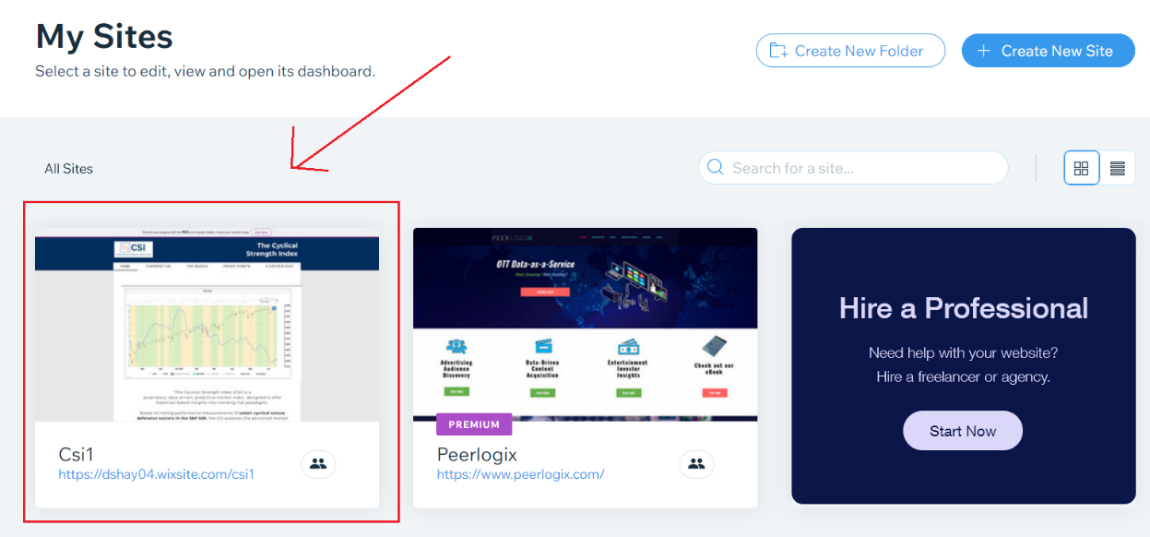

Step 3 – opening editor

After selecting the Csi1 site, you will then be able to click “Edit Site” in the top right of the page. (please see the image below)

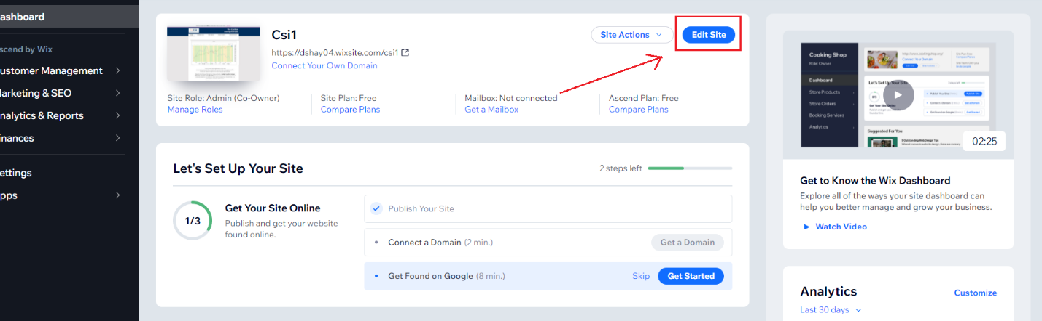

Step 4 – Where to place chart

After getting situated within the editor, you can choose to either work on the main page or instead work on a “test page” I have created. The choice I yours. I created the test page in case you’re more comfortable there but the choice is up to you. If you would like to switch to the test page, you can navigate to it by clicking the top left drop down and clicking “Test page” (see below).

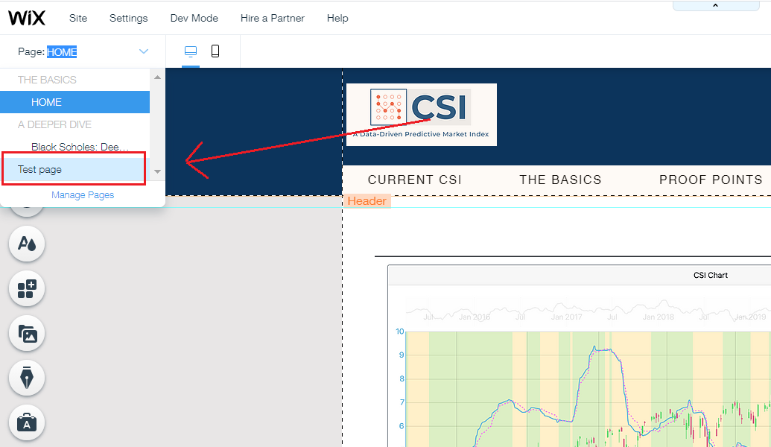

Step 5 – locating HTML embed feature

The instructions from amcharts are a little bit outdated. These instructions ask us to locate the HTML embed feature but Wix has moved it to a new location. I have highlighted how to navigate to the new location below:

